Requirements for joining the Housing Register
ID is required for all new applications or where we have written to you to request it. ID is required for all household members listed on your housing application and should be uploaded to your application.
Main/Joint Applicant
- Photo ID
- Proof of current address
- Reference from your current Landlord or professional person
Household Members
- Photo ID
- Proof of current address

- Under 16 - Proof of Child Benefit. Either the award letter or the last 3 months Bank statements showing the correct amount.

You may be required to provide additional documents if you have indicated you are a non-UK national or if you have not stated your Nationality. Please see the attached guidance on page 5.
References

New applicants are also required to provide a Landlord or Professional Reference. Identification documents and the Landlord/Professional Reference must be uploaded to your application.
References should be submitted using the Sheffield City Council reference template. If you are currently or have ever lived independently, Sections 1, 2 and 3 must be completed by your most recent landlord.
If you have never lived independently, you will need to contact us for a Professional Reference form, this can be completed by someone who knows you in a professional capacity. This could be a support worker, social worker or employer.
Please contact us if you are unsure who should complete your reference or are unable to provide one.
Using the lists below, please submit clear photographs of the required ID for all household members on your housing application.

One form of ID can be submitted if it meets the criteria as proof of identity and address, for example a valid UK driving license.

If you do not have photo ID, you must provide a passport-sized photo accompanied with a birth certificate or a DWP letter confirming your national insurance number.
Proof of child benefit is only required where children under 16 years of age are being rehoused with you. Do not send proof of your Child Tax Credit award, this will not be accepted.
Identification Documents
Proof of Address

- Recent utility bill or online statement paid in that person’s name (Dated within the last 3 Months)
- Most recent council tax statement
- Driving licence
- Home Office standard acceptance letter
- Letter from DWP for tax credits
- Bank statement - either paper or online from within the last 3months
- Wage slip from current employer
- Life assurance/Insurance policies
- Proof of all other benefits

Proof of Child Benefit

- Child benefit award letter, all pages, or
- The last 3 consecutive months bank statements showing the name of the person awarded Child Benefit (Only where award letter is not available). If you send copies of your bank statements, please remove/cover your account/sort code details.

Landlord Reference
- The reference form can be printed from the website www.sheffieldpropertyshop.org.uk. If you have any problems, please contact us on 0114 2930000 and ask for the Registrations Team.

Proof of Identity

- Marriage Certificate
- Divorce/Annulment papers
- Passport
- Deed Poll Documentation for change of name
- Current bus pass with photograph
- UK resident permit
- ID card issued by EEA/EU countries
- Home Office standard acceptance letter
- Immigration Status documentation
- NASS 35
- Citizenship card (with hologram and photo to prove age)
- Medical card
- Birth Certificate/Adoption Certificate
- Letter from Social Worker/Probation officer/Solicitor
- Driving Licence

Accepted Photo Examples (see below)

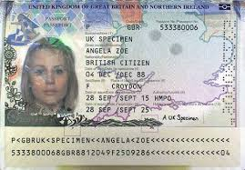
A close photo of this page of your passport. If your passport includes travel information/status also send a copy of the relevant page.

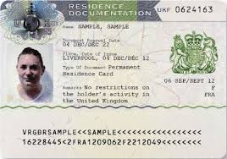

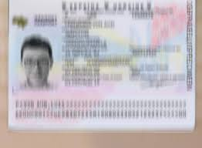

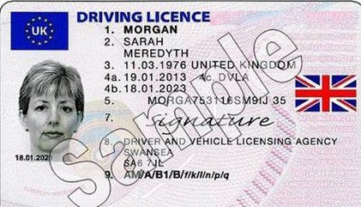

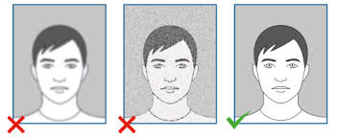
A clear passport sized photo of your face and shoulders facing forward.

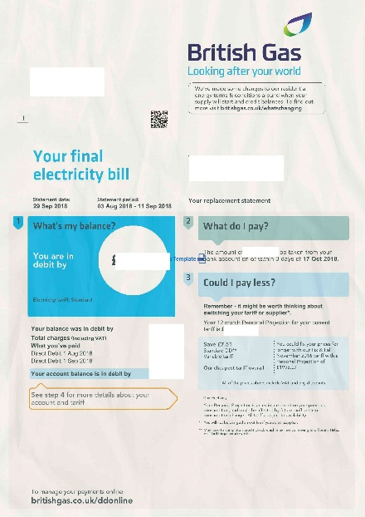
A Utility Bill dated within the last 3 months with your current address shown.

Eligibility documents required for joining the
Housing Register
Under Part VI of the Housing Act 1996, local authorities cannot allocate Council housing to people from abroad or subject to immigration control unless they are made eligible by the Allocation of Housing and Homelessness (Eligibility) (England) Regulations 2006.

As we need to establish whether you are affected by this legislation, you must provide us with proof of your current immigration status as below:
UK Nationals returning to the UK
If you have returned to the UK within the last 3 months, you will need to complete and send
- Your passport (or travel documents), with the relevant stamp(s).
- A completed Habitual Residency Test document, you will need to contact us on 0114 2930000 for this form.

Non-EEA Nationals
If you are a Non-EEA National, you will need to upload a copy of
- Your passport (or travel documents), with the relevant stamp(s).
- Letters from the Home Office - Immigration status/leave documents (front and back pages)

EEA Nationals
If you are an EEA national, please upload a copy of
- Your passport
- Proof of your settled or pre-settled status, either the status document or Home Officer letter
You can apply on the EU Settlement Scheme gov.uk web page at: www.gov.uk/settled-status-eu-citizens-families/applying-for-settled-status; or contact the EU Settlement Resolution Centre, either online or by calling 0300 123 7379, for questions about how to apply

